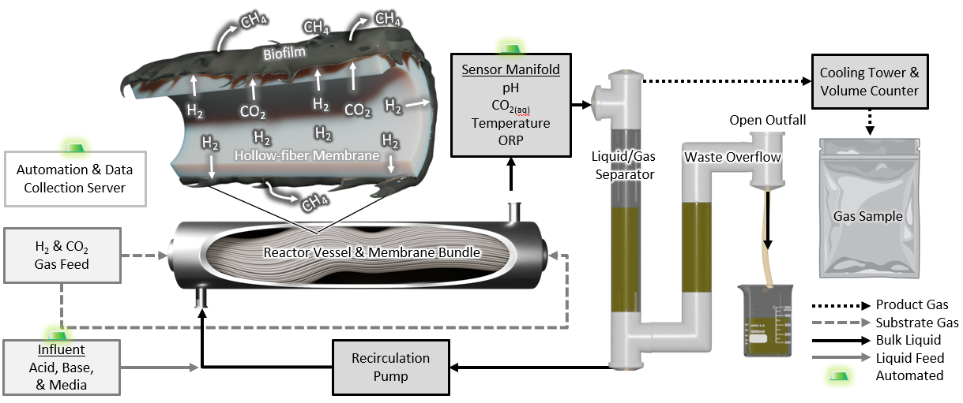
Fig. 1. Process flow diagram for the membrane biofilm reactor (MBfR). Gaseous substrates (H₂, CO₂) from pressurized tanks were delivered via mass flow controllers to the lumens of the hollow fiber membranes. Methanogenic biofilm on the membrane surface converted the substrates to CH₄. The bulk liquid (a mixture of the aqueous media and product gas) was routed through a sensor manifold after exiting the reactor vessel, measuring temperature, pH, dissolved CO₂, and oxidation reduction potential (ORP). All readings were continuously monitored via an automation and data collection server, which also controlled an influent pump delivering media continuously and acid and base as needed. Additionally, pressure gauges on the reactor effluent line and the gas influent line were used to track transmembrane pressure. After passing through the sensor manifold, the bulk liquid was routed through an open outfall with a droplet splitting screen into a liquid/gas separator, to allow separation of gas from the liquid. Product gas traveled through a cooling tower, a H₂S scrubber (not shown), and a volume counter, and was finally collected as a composite sample for subsequent analysis. Excess liquid exited the system through a passive waste overflow open to the atmosphere.

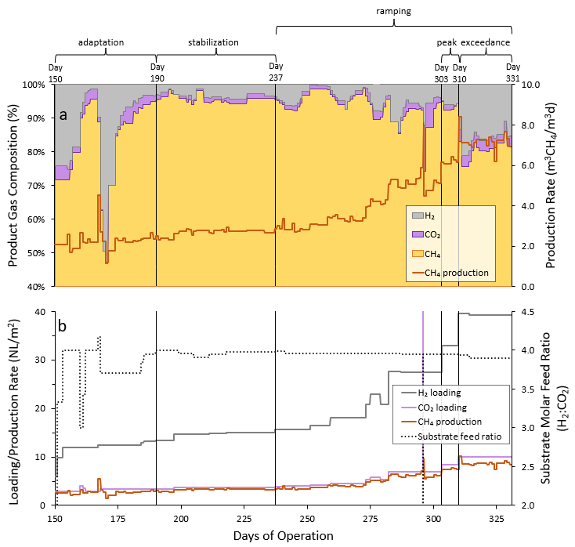
Fig. 2. Membrane biofilm reactor (MBfR) performance after a 150-day iteration and test period. Panel a) shows product gas quality on the primary axis and the specific CH₄ production rate normalized to reactor vessel volume (175 mL) on the secondary axis. Product gas quality is reported in terms of gas fractions of H₂, CO₂, and CH₄. Panel b) shows the substrate loading rates for H₂ and CO₂ and the specific CH₄ production rate normalized to membrane surface area (0.145 m²) on the primary axis, with the substrate molar feed ratio on the secondary axis. The Operational phases are labeled at the top of the figure and indicated by solid black vertical lines. All gas calculations are normalized to standard temperature (273.15 K) and pressure (1 atm).
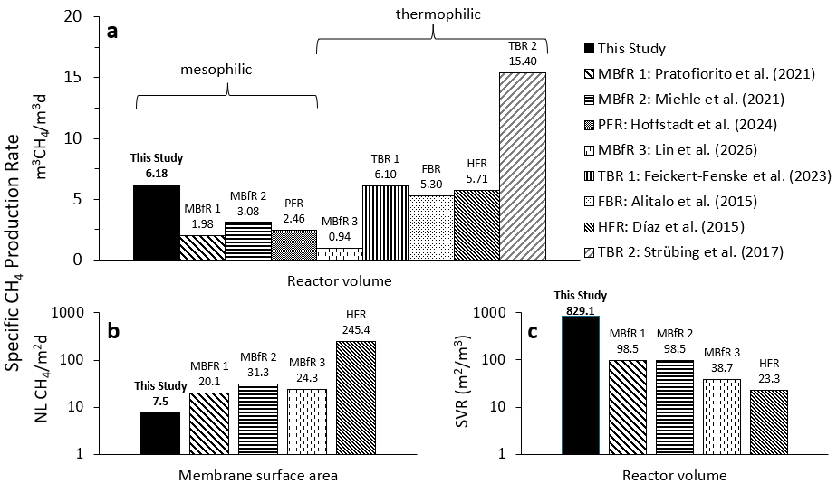Fig. 3. Comparison of maximum observed specific CH₄ production rates for ex-situ biomethanation systems. Panel a) illustrates various reactor configurations, with CH₄ production rates normalized to reactor volume, which represents the main reactor vessel and excludes peripheral equipment. Reactors are further divided according to whether they operated under mesophilic or thermophilic conditions. Panels b) and c) describe only the compared membrane-based systems. Panel b) shows production rates normalized to membrane surface area. Panel c) shows the surface to volume ratio (SVR), normalized to reactor volume. All production rate and SVR values from literature were recalculated based on reported reactor features to provide a comparative basis. Additionally, volumetric production rates were adjusted via the ideal gas law to standard temperature and pressure (STP, 0°C and 1 atm) for comparison. If authors did not specify whether they corrected gas volumetric flow rates to STP, it was assumed that the reported values were at their reactor operating temperature. Acronyms denote reactor types as follows: membrane biofilm reactor (MBfR), plug flow reactor (PFR), trickle bed reactor (TBR), fixed bed reactor (FBR), hollow fiber reactor (HFR).
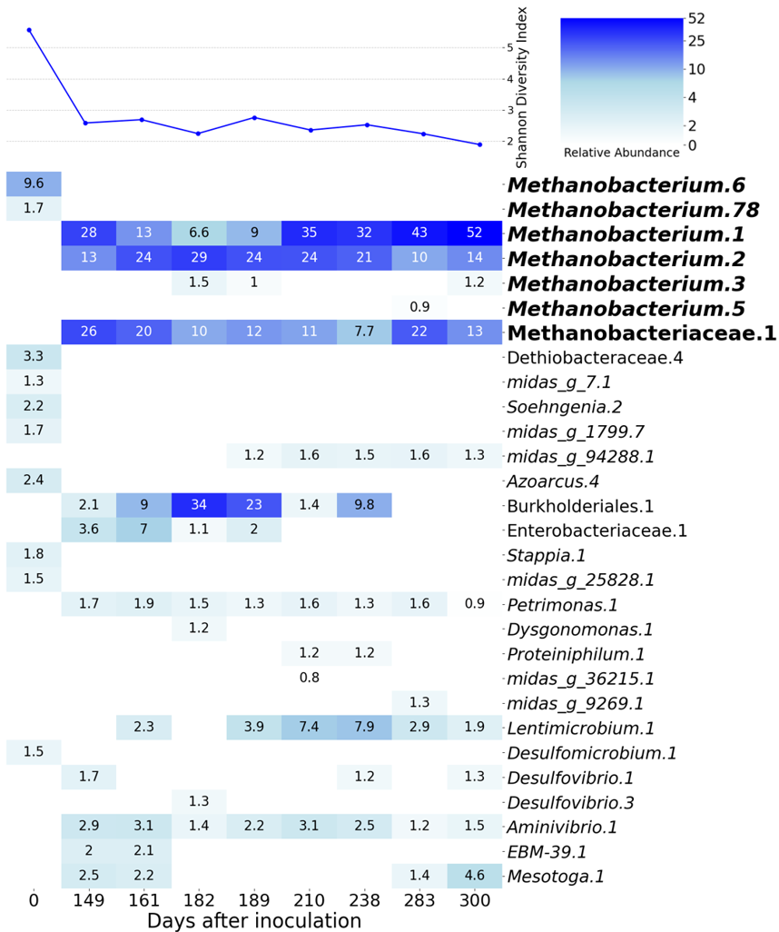Fig. 4. Relative abundances of the amplicon sequence variants (ASVs) among the 10 most abundant taxa in at least one sample. The rows are ASVs where the name is the genus-level, or next defined if genus is unavailable, MIDAS v5.3-classification of the organism and the number is an iterative count of the name to preserve uniqueness among the ASV names. The heatmaps are arranged with white and dark blue representing the lowest and highest abundance in the matrix, respectively. White cells denote zero abundance. The line plot on top of the heatmap is the Shannon Diversity Index.

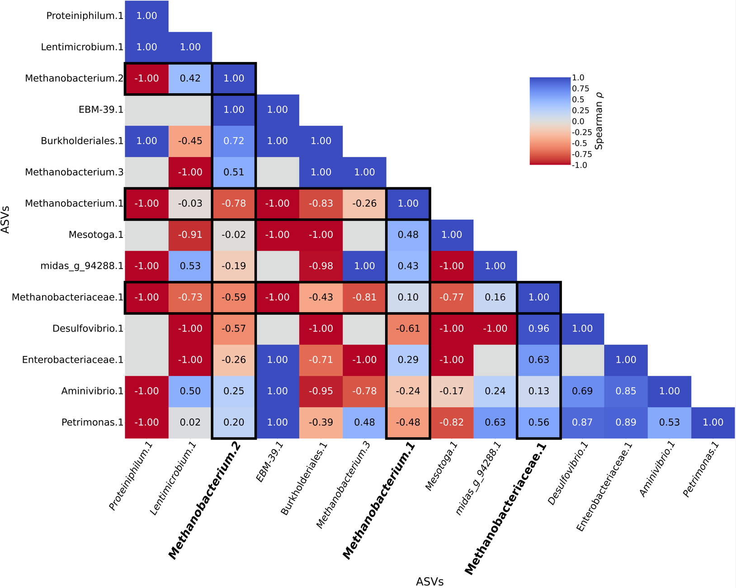
Fig. 5. A clustered heatmap of a correlational matrix of the top 10 most abundant ASVs from the inoculum and samples collected days 149-300. The three most abundant methanogenic taxa are bolded and boxed to facilitate identifying the flanking community members that are most associated. The correlations of relative abundances between the respective row and column members are Spearman’s rank correlation coefficients, where the diagonal is ρ = 1 by definition. The heatmap ranges from blue at ρ = 1, white at ρ = 0, and red at ρ = -1. All associations presented here are statistically significant correlations (p < 0.05).
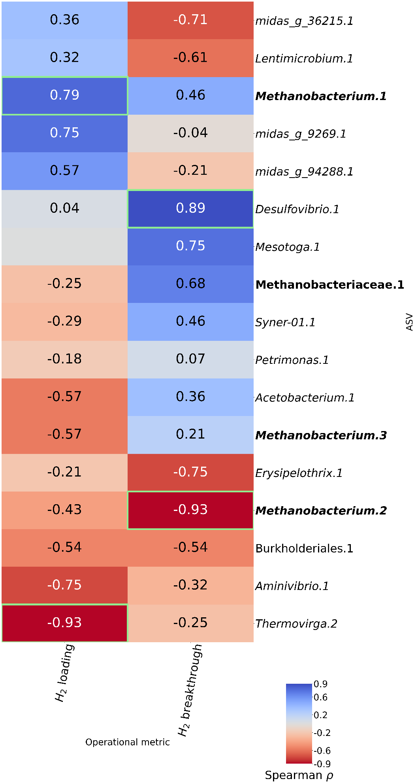

Fig. 6. A clustered heatmap of a correlational matrix of the top 10 most abundant ASVs from the inoculum and samples collected days 149-300 relative to 1) the molar H₂ loading rate and 2) the molar rate of H₂ breakthrough in the product gas. The methanogenic taxa are bolded and boxed. The correlations of relative abundances between the respective row and column members are Spearman’s rank correlation coefficients, where the diagonal is ρ = 1 by definition. The heatmap ranges from blue at ρ = 1, white at ρ = 0, and red at ρ = -1. Green box outlines indicate statistically significant correlations (p < 0.05).

